**TALK1: TeraScale NLP To Accelerate Research** **1**

Abstract 1

Logistics 2

Contributions 2

Longformer 2

Exploiting structure In Document 3

Sharing Dataset 3

Discovery: Recommender for Scientic Articles 3

Data Collection 5

Inference 5

Discovery: Personalized and Alert Explanation 7

Decide: How to Decide Whether To Read Paper 7

Dataset: 8

Read 10

**TALK2: What's Next In Infrastructure for ML** **11**

Abstract 11

Logistics 11

ML is different from Traditional Software 12

Approach1: Systems to Support production ML 13

Approach2: Production friendly ML methods 14

**TALK: Data** **19**

**TALK3: Toward an Easy to Use AI Platform: Data,Algorithm, and System** **19**

Abstract 19

Data Preparation 20

# **TALK1: TeraScale NLP To Accelerate Research**

## Abstract

## Logistics

<https://virtual.2021.kdd.org/plenary_session_invited_talk_by_Daniel_S_WELD.html>

10:45AM-11:30AM

### Contributions

#### Longformer

### 

Transformers attention is n2, so does not scale well.

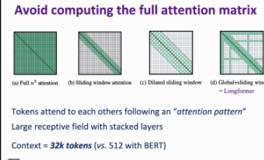

LongFormer can handle 32k tokens!

For loop is memory efficient, but not computation efficient

Sliding window --> dilated sliding window → global+sliding window

#### Exploiting structure In Document

Exploiting Strucutre of Docuemnt (Hierarchy): links, titles, references

#### Sharing Dataset

research.semanticsscholor.rog.resources

CORD-19

### Discovery: Recommender for Scientic Articles

#### 

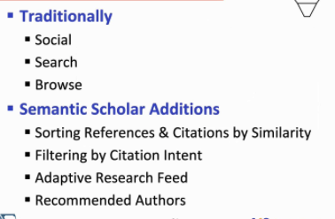

Recommender Challenges for Scientific papers

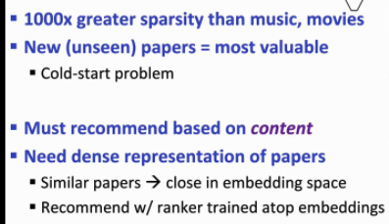

New paper is more interesting

Sparse → cannot use collaboaritive

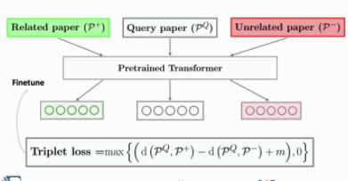

Use tripler loss: minimize distance between query, paper+, maximize diff between paper+, paper=

#### Data Collection

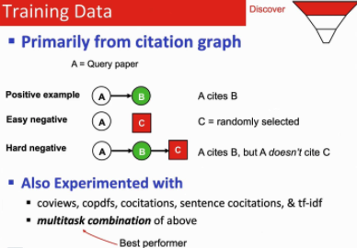

#### Inference

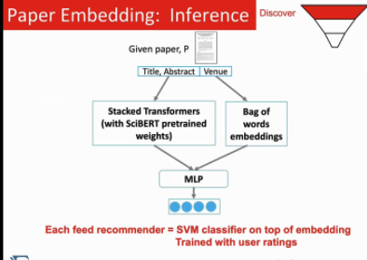

Results/Analysis

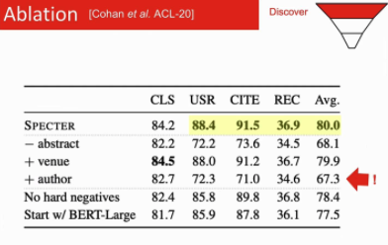

Model does not take into account of authors

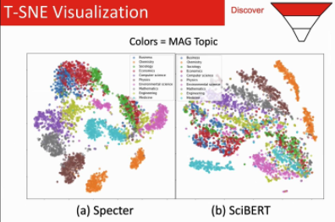

### Discovery: Personalized and Alert Explanation

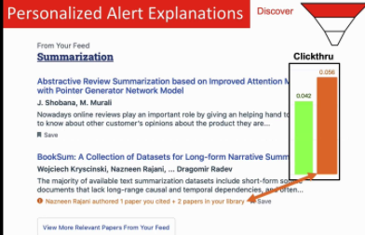

### Decide: How to Decide Whether To Read Paper

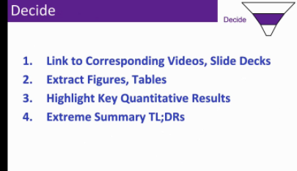

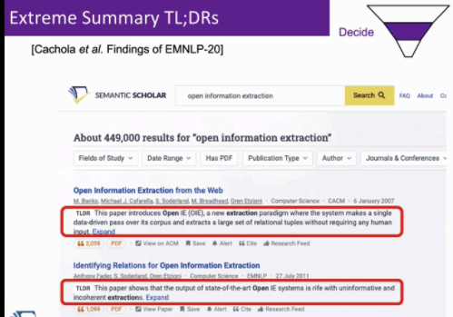

~15 tokens long!!!

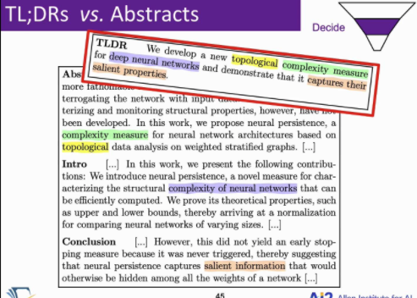

#### Dataset:

Scrape author TLDR

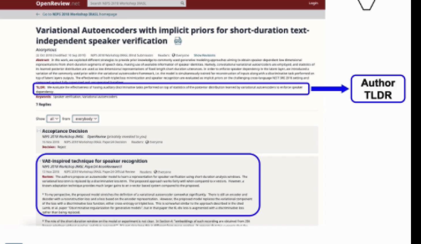

But still want more dataset: take open reviews and have an annotator condensi it more

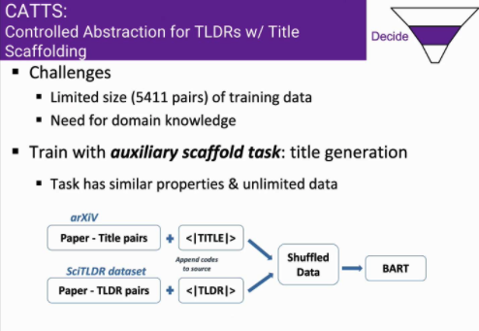

5400 is still too little. Augment with title generation task

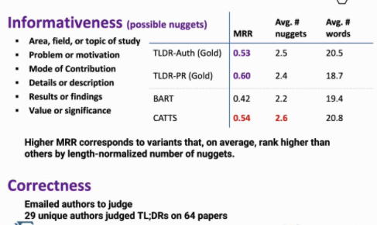

### Read

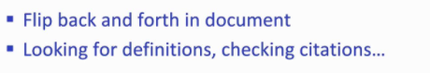

Reading is hard because you lose flow going back and forth



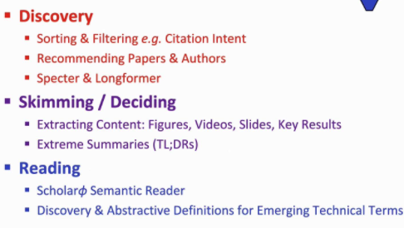

# **TALK2: What's Next In Infrastructure for ML**

## Abstract

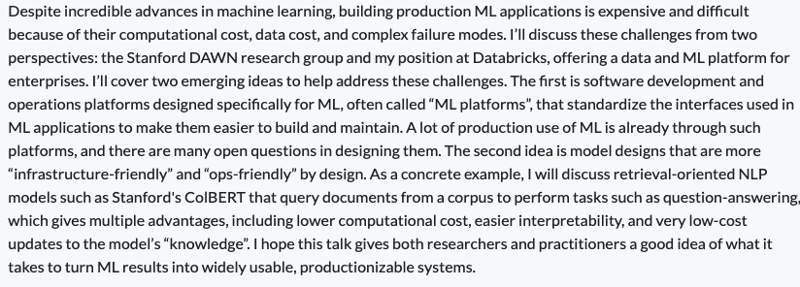

## Logistics

Monday, 1:45PM - 2:30 PDT

https://virtual.2021.kdd.org/plenary_session_invited_talk_by_Matei_ZAHARIA.html

## ML is different from Traditional Software

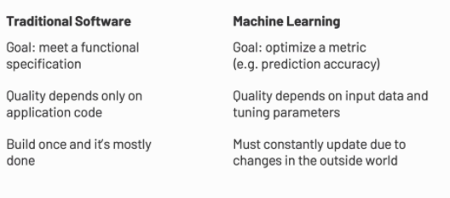

Data is harder to check for quality, that unit tests

* Training is getting easier; lifecyle is not there yet.

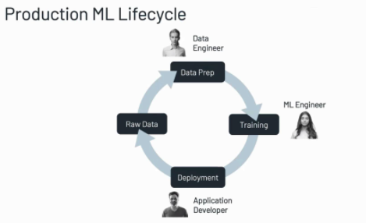

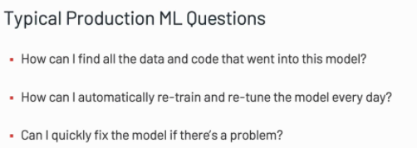

## Approach1: Systems to Support production ML

* ML Platforms, new abstractions
* 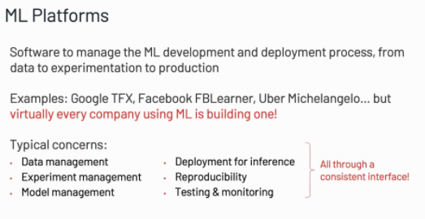
* 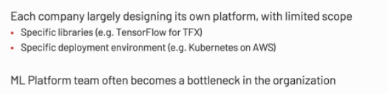
* Companies with deep expertise and $building their own. Even after its built, need alot of support new models
* Google Cloud, Amazon Sagemaker:
* Open source code: ML
  + 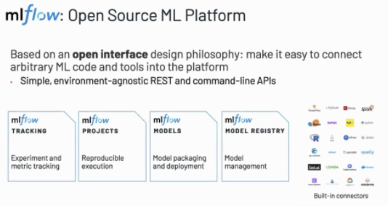
* Model base assertion
  + 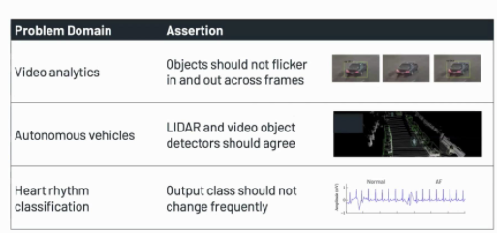
  + https://arxiv.org/pdf/2003.01668.pdf

## Approach2: Production friendly ML methods

* Ex: Retrieval-based NLP
* Problem with black box function models
  + 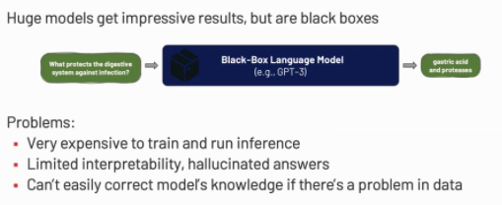
  + Simon’s NER model: how to fix one bad case
* Retrieval Based NLP
  + 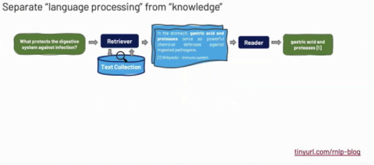
  + Retrieva and reader model can be alot smaller than deep NN
  + 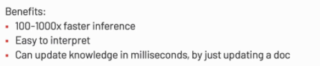
  + 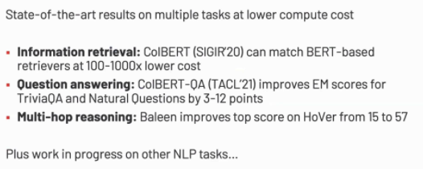
  + 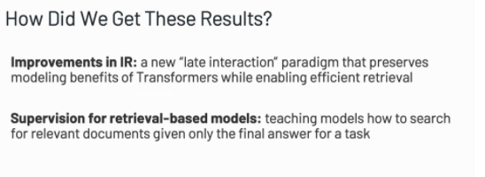
    - IR: hash or invert table
* Intuition fo IR
  + Prevous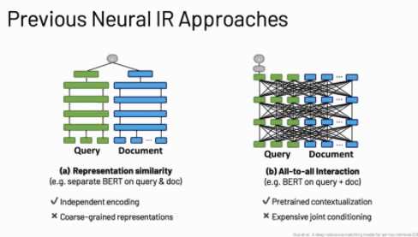
    - Method1:
      * Retrieval: Nearest neighbor lookup
      * Not good because document can have mulptple representations
    - Method2: (Google)
      * Inference is expensive: look at thousands
  + Colbert
    - 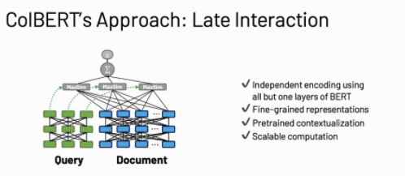
    - Doing interaction at the latest level of query and document at the last level; efficient with index
    - 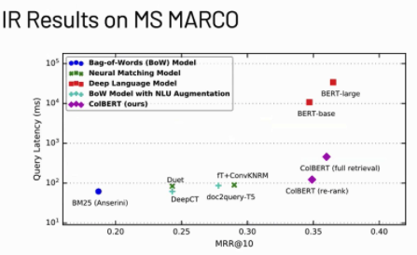
    - Reference
      * <https://github.com/stanford-futuredata/ColBERT>
      * [Stanford](https://hai.stanford.edu/news/moderate-proposal-radically-better-ai-powered-web-search?utm_source=Stanford+HAI&utm_campaign=97fd06f5fa-Mailchimp_HAI_Newsletter_July_2021_2&utm_medium=email&utm_term=0_aaf04f4a4b-97fd06f5fa-214011318)
* Colbert applied to Question and Answering
  + 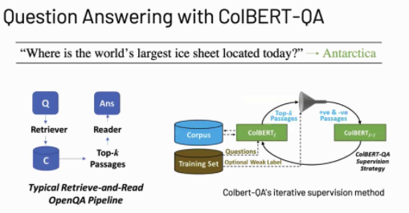
  + Use the answer to the question as a weak supervision for next iteration
  + 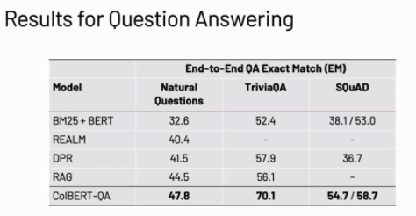
* Future Opportunities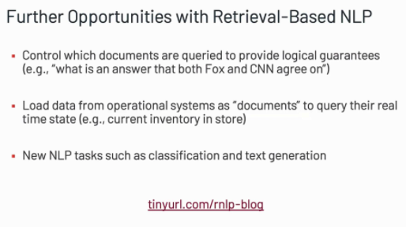

# **TALK: Data**

# 

There are deficiencies in all these approaches.

If you make your own, is dataset balanced; what’s the license? How was it collectd?

# **TALK3: Toward an Easy to Use AI Platform: Data,Algorithm, and System**

## Abstract

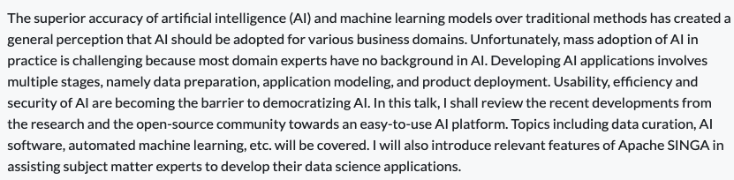

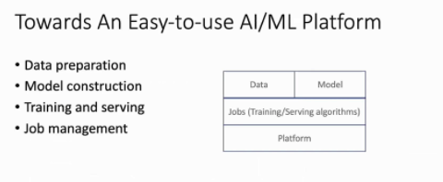

## Data Preparation

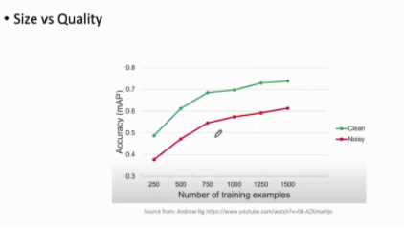

* More data can help with model
* But more data may require more labels, ie crowd-sourcing. But need to define task consistently. Combining workers results needs to be analyzed; can introduce noise

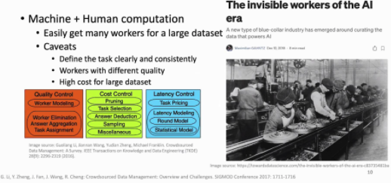

Another approach, is to use automatic labeling via weak supervision

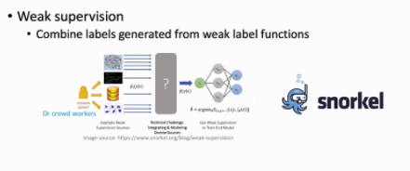

What is snorkel? TODO: look into it. Seems to be some sort of label probabage

Another approach

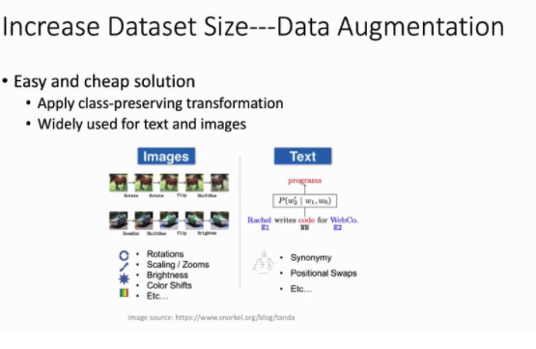

Graph augmentation:

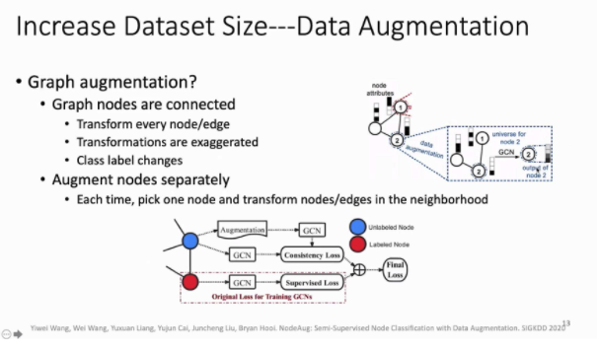

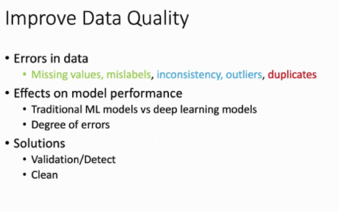

5 types of errors. Greens mean fixing these wil improve error changes. Blue means no impact.

DL are somewhat immune to some level of errors.

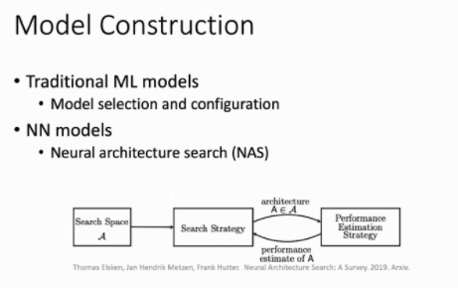

Is NAS auto-ml? Or some sort of grid search.

